**Empowering Smart Grid for the Future of Urban Centers**

**Submitted**

**By:**

1. **AHMED ABDULRAHMAN ABDULLAH BIN ALFAQEEH  
   BU21EECE0200026**
2. **SEEPALA SIVA KUMAR   
    BU21EECE0200038**
3. **YASHWANTH M   
   BU21EECE0200033**

**Under the Guidance of:**

**Dr. P.SUNDARARAMAN**

**(Duration: Date/Month/Year to Date/Month/Year)**



**Department of Electrical, Electronics and Communication Engineering**

**GITAM School of Technology**

**GITAM**

**(DEEMED TO BE UNIVERSITY)**

**(Estd. u/s 3 of the UGC Act 1956)**

**NH 207, Nagadenehalli, Doddaballapur taluk, Bengaluru-561203 Karnataka, INDIA.**

**DECLARATION**

**We declare that the project work contained in this report is original and it has been done by us under the guidance of my project guide.**

**Name: AHMED ABDULRAHMAN ABDULLAH BIN ALFAQEEH**

**Date: Signature of the Student**



**Department of Electrical, Electronics, and Communication Engineering**

**GITAM School of Technology, Bengaluru-561203**

**CERTIFICATE**

**This is to certify that AHMED ABDULRAHMAN ABDULLAH BIN ALFAQEEH bearing (Regd. No.: BU21EECE0200026) has satisfactorily completed Mini Project Entitled in partial fulfillment of the requirements as prescribed by University for VIIth semester, Bachelor of Technology in “Electrical, Electronics and Communication Engineering” and submitted this report during the academic year 2024-2025.**

**Signature of the Guide Signature of HOD**

**Table of contents:**

**Chapter 1: Introduction 1**

1.1 Overview of the problem statement 1

1.2 Objectives and goals 1

**Chapter 2 : Literature Review 2**

**Chapter 3 : Strategic Analysis and Problem Definition 3**

3.1 SWOT Analysis 3

3.2 Project Plan - GANTT Chart 3

3.3 Refinement of problem statement 3

**Chapter 4 : Methodology 4**

4.1 Description of the approach 4

4.2 Tools and techniques utilized 4

4.3 Design considerations 4

**Chapter 5 : Implementation 5**

5.1 Description of how the project was executed 5

5.2 Challenges faced and solutions implemented 5

**Chapter 6:Results 6**

6.1 outcomes 6

6.2 Interpretation of results 6

6.3 Comparison with existing literature or technologies 6

**Chapter 7: Conclusion 7**

**Chapter 8 : Future Work 8**

Here write Suggestions for further research or development Potential improvements or extensions 8

**References 9**

# **Chapter 1: Introduction:**

The increasing demand for energy and ever-growing dependence on fossil fuels globally have called for a big change towards renewable energy sources in electricity production. However, the integration of renewable energy systems and energy management has considerable challenges to handle. The smart grid system has handled these aspects by upgrading existing power infrastructure with advanced technologies, including two-way flow of power, communication, distributed generation, and automated controls. The entire system will make energy generation, transmission, distribution, and consumption more interactive to utilize energy in a better way, reduce the cost, and enhance the reliability of energy. Some of the most important factors involve energy management and changing the demand pattern, which is emphasized to minimize the requirements of energy and shifting its usage during peak periods to enhance the efficiency and security of the system.

* 1. **Overview of the problem statement:**

The increasing energy demands of urban centers are overwhelming traditional power grids, which struggle to integrate renewable energy sources, manage real-time energy consumption, and ensure a reliable supply. These grids are prone to inefficiencies and outages, making them unsustainable in the long term. To address these challenges, there is an urgent need for the development of smart grid systems that can enhance energy management, improve reliability, and support the integration of renewable energy for the future of urban infrastructure.

## **1.2 Objectives and goals**

1. Implementing a scalable and flexible smart grid to support expanding urban centers.
2. Integrating different energy sources like solar and wind turbines to reduce dependency on fuel and lower carbon footprints in urban areas.
3. Integrating IoT technologies for better reliability and accelerating fault detection and two-way communications across the electric system of an area.
4. Real-time monitoring and control, enabling data-driven decision-making for enhanced energy management.

**Main Goals**

1. Enhance Grid Scalability and Flexibility
2. Improve Grid Reliability and Efficiency
3. Empower Real-Time Monitoring and Control

**Additional Goals**

1. Gain proficiency in multiple software platforms used for smart grid design, simulation, and analysis.
2. Learn how to effectively integrate and manage IoT devices within the smart grid to enhance monitoring+.

**Chapter 2 : Literature Review:**

|  |  |  |  |  |
| --- | --- | --- | --- | --- |
| **S.No** | **Article** | **Authors** | **Published on** | **Description** |
| 1 | [Investigating the use of MATLAB/SIMULIK and LabVIEW in Microgrid Modelling and Simulation](https://github.com/AhmedBU21EECE0200026/AhmedBU21EECE0200026-EMPOWERING-SMART-GRID-FOR-THE-FUTURE-OF-URBAN-CENTERS/blob/main/Research%20Paper/Laban.pdf) | Mahmoud Laban | 25 Aug 2017 | He has modeled and simulated a microgrid using MATLAB/and Simulink, but he did not integrate the IoT devices that enable 2-way communications. |
|  | [Recent advancement in smart grid technology: Future prospects](https://github.com/AhmedBU21EECE0200026/AhmedBU21EECE0200026-EMPOWERING-SMART-GRID-FOR-THE-FUTURE-OF-URBAN-CENTERS/blob/main/Research%20Paper/1-s20-S2090447920301064-main_240717_090001.pdf) | Osama Majeed Butt a,⇑ , Muhammad Zulqarnain a , Tallal Majeed Butt | 7 July 2020 | Future research in smart grids focuses on improving forecasting, optimizing power flow, enhancing communication, integrating microgrids, managing energy demand, ensuring standards, scalability, cost-effectiveness, data security, and automating generation, transmission, and distribution. |
| 3 | [Solar power integration in Urban areas: A review of design innovations and efficiency enhancements](https://github.com/AhmedBU21EECE0200026/AhmedBU21EECE0200026-EMPOWERING-SMART-GRID-FOR-THE-FUTURE-OF-URBAN-CENTERS/blob/main/Research%20Paper/WJARR-2024-0168.pdf) | Emmanuel Augustine Etukudoh 1, *, Zamathula Queen Sikhakhane Nwokediegwu 2, Aniekan Akpan Umoh 3, Kenneth Ifeanyi Ibekwe 4, Valentine Ikenna Ilojianya 5 and Adedayo Adefemi | 16 Jan 2024 | Integrating IoT devices into the smart grid is the future trend in the structure of power systems, including the use of smart city technologies to optimize solar energy capture and grid reliability in urban environments. |
| 4 | [Modeling and Control for Smart Grid Integration of Solar/Wind Energy Conversion System](https://github.com/AhmedBU21EECE0200026/AhmedBU21EECE0200026-EMPOWERING-SMART-GRID-FOR-THE-FUTURE-OF-URBAN-CENTERS/blob/main/Research%20Paper/Modeling_and_control_for_smart_grid_integration_of_solar_wind_energy_conversion_system.pdf) | Emad Natsheh, Alhussein Albarbar, Javad Yazdani | _________________ | Novel model of a smart grid-connected PV/WT hybrid system, incorporating photovoltaic arrays, wind turbines, and control components, developed using MATLAB/SIMULINK. By utilizing real-time data and the Perturb and Observe (P&O) algorithm for maximum power point tracking (MPPT), the model demonstrates effective performance optimization and system reliability under various operating conditions |

# **Chapter 3 : Strategic Analysis and Problem Definition**

# **3.1 SWOT Analysis**

**Strengths**

S1. High Efficiency

S2. Fast Fault Detection

S3. Energy saving

**Weaknesses**

W1. High Capital Cost

W2. Dependency On Weather Conditions

W3. Complex Implementation

W4. Data Storage

**Opportunities**

O1. Integration Of Renewable Sources

O2. Reduction Of Carbon Emission

O3. Support For Electric Vehicles

O4. Latest research areas

**Threats**

T1. Cybersecurity Risks

T2. scarcity of components

### **3.2 Project Plan - GANTT Chart**

##### **3.3 Refinement of problem statement**

Urban centers are rapidly expanding, driving a surge in energy demand that traditional power grids are ill-equipped to handle. These conventional grids are designed for one-way energy flow from centralized power plants to consumers, which limits their ability to efficiently integrate decentralized renewable energy sources like solar and wind. As a result, they are prone to inefficiencies, higher operational costs, and frequent power outages, particularly during peak loads or unexpected disruptions.

Moreover, traditional grids lack real-time monitoring and automated control, making it difficult to manage energy distribution effectively. This results in significant energy losses, delays in fault detection, and a limited ability to optimize energy usage. With the rising global focus on sustainability and the need for resilient energy systems, there is an urgent demand for smarter, more flexible energy infrastructures.

A smart grid system can address these challenges by integrating renewable energy sources, enabling two-way communication between energy producers and consumers, and using advanced technologies like IoT for real-time monitoring and control. The implementation of a smart grid will enhance energy efficiency, improve grid reliability, and ensure the sustainable development of urban centers.

**Chapter 4: Methodology**

## **4.1 Description of the approach**

We used the bottom to up approach-started using MATLAB Simulink to design and simulate a smart grid system that integrates renewable energy sources, including a solar farm, wind farm, diesel generator, and battery storage. Each component is first modeled separately before being integrated into a unified smart grid model. The integrated system connects to various load types—inductive, capacitive, and resistive—and utilizes environmental data such as temperature, solar irradiance, and wind speed to simulate real-world conditions for the solar and wind farms. Protection mechanisms are included to safeguard the system.

The approach follows a step-by-step development process, starting with data collection on energy consumption and generation. It emphasizes efficient energy flow. Detailed simulations are conducted to analyze system performance, focusing on grid stability, fault detection.

### **4.2 Tools and techniques utilized**

* **MATLAB**: Used to run codes for uploading data and writing programs for Maximum Power Point Tracking (MPPT) systems.
* **Simulink**: Used to design and simulate the smart grid model visually.
* **Excel**: Used to manage and organize data, like temperature, solar irradiance, and wind speed.
* **Gantt Chart**: Used to track our progress and keep our tasks organized throughout the project.

#### **4.3 Design considerations**

* **Integration of Energy Sources**: The solar farm, wind farm, diesel generator, and battery storage systems are modeled and then integrated into a unified smart grid model in MATLAB Simulink.
* **Load Variability**: Different types of loads (inductive, capacitive, resistive) are used to assess the system’s stability and performance.
* **Environmental Data Inputs**: Real-world data for temperature, solar irradiance, and wind speed are fed into the system to simulate the performance of the solar and wind farms.

**Chapter 5 : Implementation**

## **Description of how the project was executed**

The project was executed in several phases. First, we collected data on energy consumption and generation, which helped us understand the requirements for the smart grid system. Using MATLAB, we wrote codes to upload this data and implement algorithms for Maximum PowerPoint Tracking (MPPT) systems.

Next, we designed individual models for the solar farm, wind farm, diesel generator, and battery storage in Simulink. Each component was simulated separately before being integrated into a single smart grid model. We connected the integrated system to different types of loads—inductive, capacitive, and resistive—to assess performance under various conditions then at the end, we ran the simulation and got the results.

### **5.2 Challenges faced and solutions implemented**

1. **Data Collection Issues**

**Problem**: We initially collected data on sunny days, which limited our ability to test the model under different weather conditions.

**Solution**: To simulate various scenarios, we manually entered lower values for wind speed and solar irradiance, allowing us to assess the model's performance in diverse conditions.

1. **Model Design Compatibility**

**Problem**: While designing the systems individually, we faced compatibility issues with PowerGUI, as some models were continuous, others were discrete, and some were in phasor form.

**Solution**: To ensure smoother execution, we converted all models to discrete form, which required adjusting numerous parameters across the different models for consistency.

1. **Simulation Time Constraints**

**Problem**: The complexity of the system and the discrete nature of PowerGUI prevented us from running the simulation for extended periods.

**Solution**: We modified the time data to operate the model with 100 values over five seconds. This approach allowed us to test the system under different conditions within a shorter timeframe.

1. **Wind Farm Performance**

**Problem**: During the wind farm simulation, we initially designed the system without a converter, resulting in outputs that did not meet our expectations.

**Solution**: We incorporated an AC to DC converter, followed by a DC to DC boost converter, and then converted the output to three-phase power. This significantly improved the performance and reliability of the wind farm.

**Chapter 6:Results**

## **6.1 outcomes**

We successfully designed and built a smart grid system that integrates four power sources: a solar farm, wind farm, diesel generator, and battery storage. These sources supply power to four types of loads, including inductive, capacitive, resistive, and mixed loads. Here’s the contribution from each source:

* Solar Farm: 20% of total power.
* Wind Farm: 100% of its capacity.
* Diesel Generator: 20% of total power.
* Battery Storage: 20% of total power.

The solar farm and wind farm can adjust their outputs based on real-time data, allowing the system to be more responsive to actual conditions.

While the combined power met our load demands, we noticed some imbalance in power generation due to the absence of a control system. This is something we plan to address in the next phase.

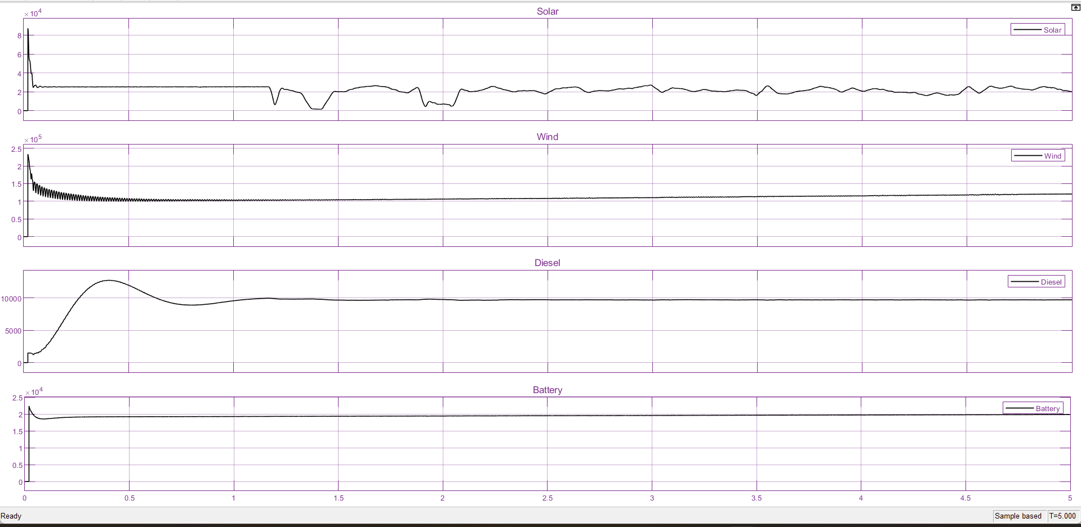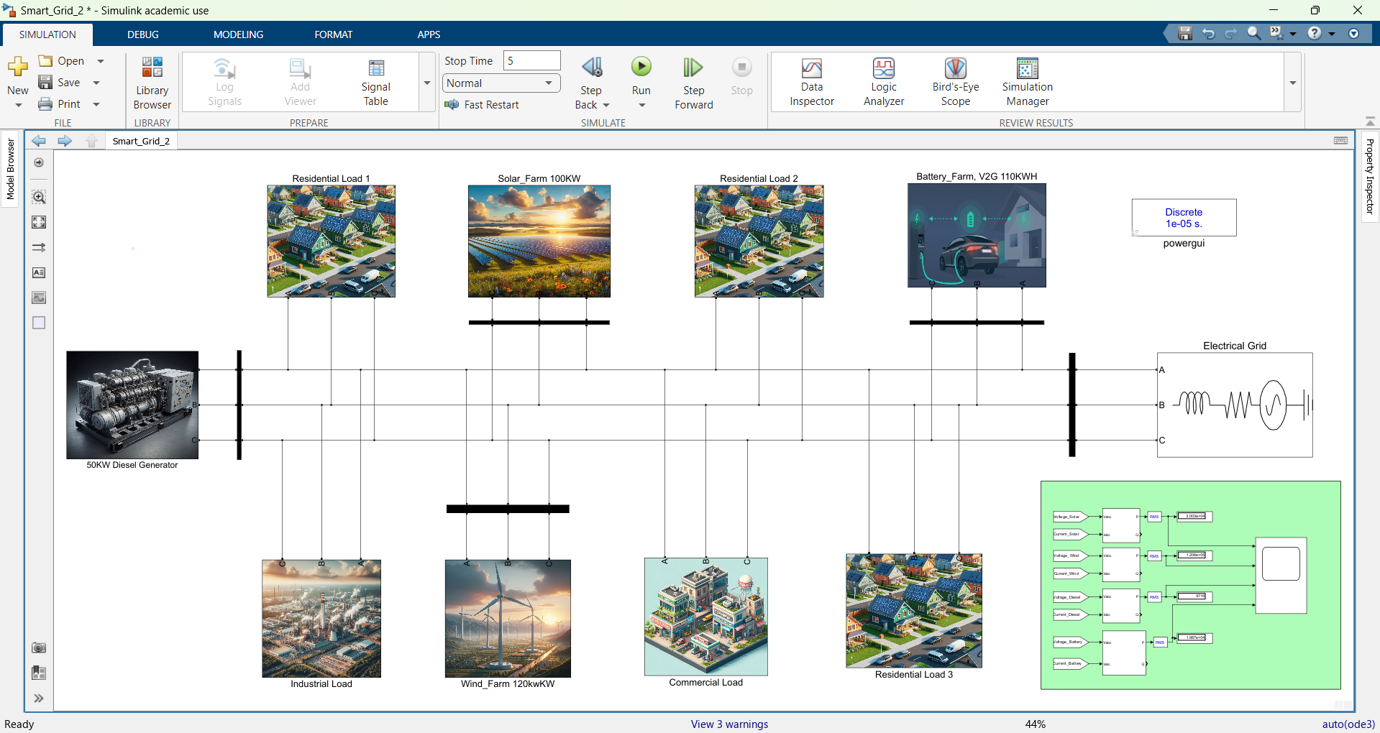

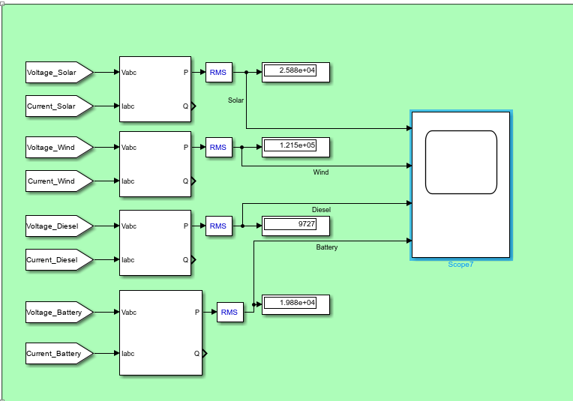

**6.2 Interpretation of results**

Our grid is functional and meets energy demands, but there is room for improvement in power distribution. The wind farm operated at full capacity, while the solar farm, diesel generator, and battery storage contributed less than their potential.

The ability of the solar and wind farms to adapt based on real-time data is advantageous. However, without a control system, we faced mismatches in power generation and load requirements. Adding a control system will help each source contribute more effectively based on current demand.

#### **6.3 Comparison with existing literature or technologies**

Compared to existing smart grid technologies, our project shows promise but currently lacks a sophisticated control system to manage power flow dynamically. Existing studies often focus on directly measuring current and voltage without implementing a comprehensive control framework. In contrast, our approach involves implementing each subsystem individually before integrating them together, allowing for a more modular and thorough design.

Despite these limitations, our system demonstrates significant potential for balancing renewable and conventional energy sources. In future phases, we plan to develop a control system to enhance our grid's efficiency and adaptability. The ability of the solar and wind farms to respond to real-time data is a critical step toward creating a more efficient energy system

#### **Chapter 7: Conclusion**

In this project, we successfully designed and integrated a hybrid energy system that includes a solar farm, wind farm, diesel generator, and battery storage system. The solar farm operates based on solar irradiance and temperature data, while the wind farm functions using wind speed data. These energy sources were connected to different types of loads (resistive, capacitive, and inductive), and circuit breakers were incorporated for system protection and control. The project demonstrates efficient energy management by combining renewable sources with a backup generator, ensuring a stable power supply.

**Chapter 8 : Future Work**

In the future, IoT devices will be integrated into the system for enhanced real-time monitoring and remote control. This will enable better supervision, data collection, and optimization of the system's overall performance. The next phase will focus on improving the automation and reliability of the hybrid energy system for real-world applications in urban centers.

#### **References**

[Recent advancement in smart grid technology: Future prospects](https://github.com/AhmedBU21EECE0200026/AhmedBU21EECE0200026-EMPOWERING-SMART-GRID-FOR-THE-FUTURE-OF-URBAN-CENTERS/blob/main/Research%20Paper/1-s20-S2090447920301064-main_240717_090001.pdf)

[Investigating the use of MATLAB/SIMULIK and LabVIEW in Microgrid Modelling and Simulation](https://github.com/AhmedBU21EECE0200026/AhmedBU21EECE0200026-EMPOWERING-SMART-GRID-FOR-THE-FUTURE-OF-URBAN-CENTERS/blob/main/Research%20Paper/Laban.pdf)

[Modeling and Control for Smart Grid Integration of Solar/Wind Energy Conversion System](https://github.com/AhmedBU21EECE0200026/AhmedBU21EECE0200026-EMPOWERING-SMART-GRID-FOR-THE-FUTURE-OF-URBAN-CENTERS/blob/main/Research%20Paper/Modeling_and_control_for_smart_grid_integration_of_solar_wind_energy_conversion_system.pdf)

[Solar power integration in Urban areas: A review of design innovations and efficiency enhancements](https://github.com/AhmedBU21EECE0200026/AhmedBU21EECE0200026-EMPOWERING-SMART-GRID-FOR-THE-FUTURE-OF-URBAN-CENTERS/blob/main/Research%20Paper/WJARR-2024-0168.pdf)